**KPI’S REQUIREMENT**

**Total revenue**

USE [Pizza DB]

SELECT* FROM Pizza_sales

Select SUM([total_price])as Total_revenue from [dbo].[pizza_sales]

= 817860.05083847

Average order value

Select SUM([total_price])/COUNT(DISTINCT(ORDER_ID)) as Avg_order_value from [dbo].[pizza_sales]

= 38.3072623343546

**Total pizza sold**

Select SUM([quantity])as Total_pizza_sold from [dbo].[pizza_sales]

= 49574

Total orders

Select COUNT(DISTINCT order_id) as Total_orders from [dbo].[pizza_sales]

= 21350

Average pizzas per order

Select SUM([quantity])/COUNT(DISTINCT order_id) from [dbo].[pizza_sales]

= 2

Here, the MS SQL SERVER is trying to round of the orginal value

So there is a need to change the data type

Select CAST(CAST(SUM([quantity])AS DECIMAL(10,2))/ CAST(COUNT(DISTINCT order_id)AS DECIMAL(10,2)) AS DECIMAL(10,2)) as Avg_pizza_per_order from [dbo].[pizza_sales]

= 2.32

**DAILY TREND FOR TOTAL ORDERS**

Select DATENAME(DW,[order_date] ) AS order_day, COUNT(DISTINCT [order_id]) AS Total_orders from pizza_sales

GROUP BY DATENAME(DW, [order_date])

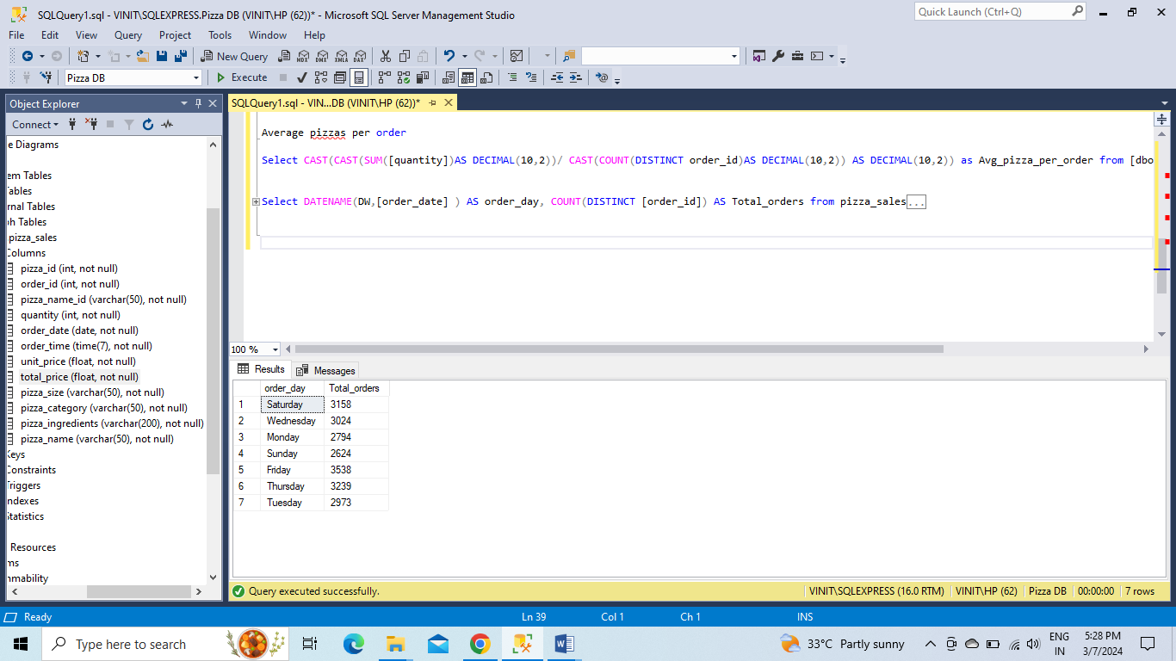

**MONTHLY TREND FOR TOTAL ORDERS**

Select DATENAME(MONTH,[order_date]) AS Month_Name, COUNT(DISTINCT [order_id]) AS Total_orders from [dbo].[pizza_sales]

GROUP BY DATENAME(MONTH, [order_date])

ORDER BY Total_orders DESC

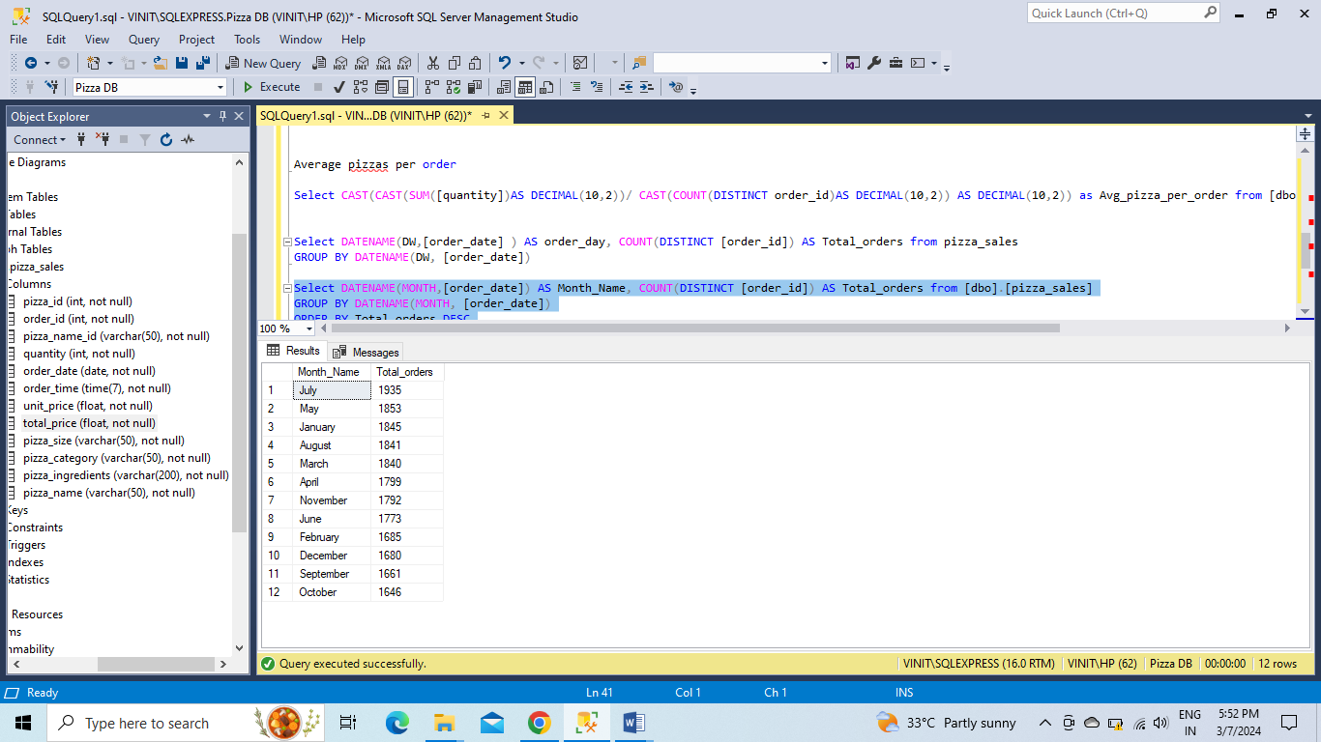

**% of Sales by Pizza Category**

Select [pizza_category],SUM([total_price]) AS Total_price, SUM([total_price])/

(Select SUM([total_price]) from [dbo].[pizza_sales])*100 AS PCT from [dbo].[pizza_sales]

GROUP BY [pizza_category]

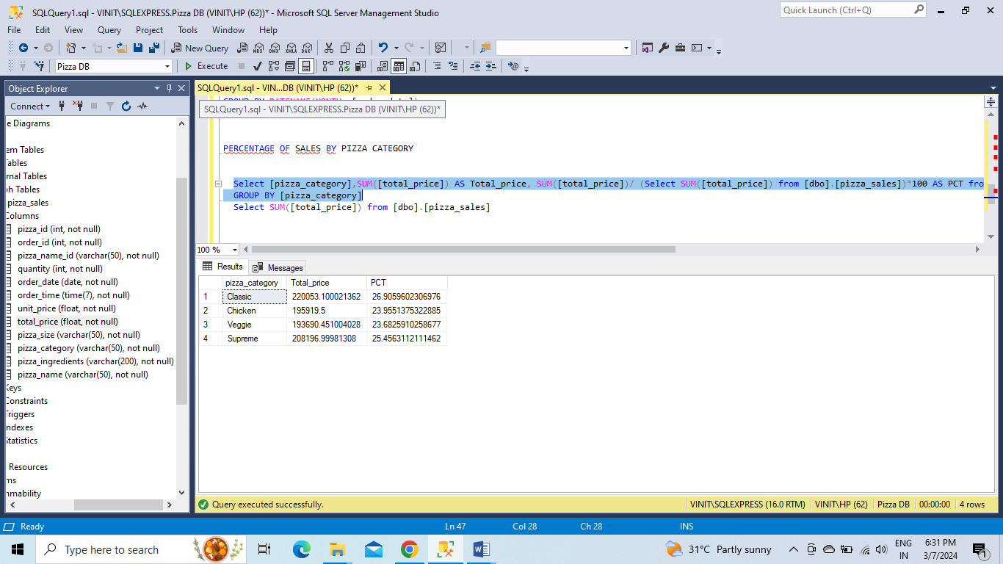

IF WE NEED A SPECIFIC MONTHLY PERCENTAGE OF SALES, for example January, we can write the query as

Select [pizza_category],SUM([total_price]) AS Total_price, SUM([total_price])/ (Select SUM([total_price]) from [dbo].[pizza_sales] WHERE MONTH(order_date)=1)*100 AS PCT from [dbo].[pizza_sales]

WHERE MONTH(order_date)=1

GROUP BY [pizza_category]

WE CAN JUST CHANGE THE NUMBER 1 TO KNOW THE OTHER MONTHLY TRENDS

**% of Sales by Pizza Size**

SELECT pizza_size, CAST(SUM(total_price) AS DECIMAL(10,2)) as total_revenue,

CAST(SUM(total_price) * 100 / (SELECT SUM(total_price) from [dbo].[pizza_sales]) AS DECIMAL(10,2)) AS PCT

FROM [dbo].[pizza_sales]

GROUP BY pizza_size

ORDER BY pizza_size

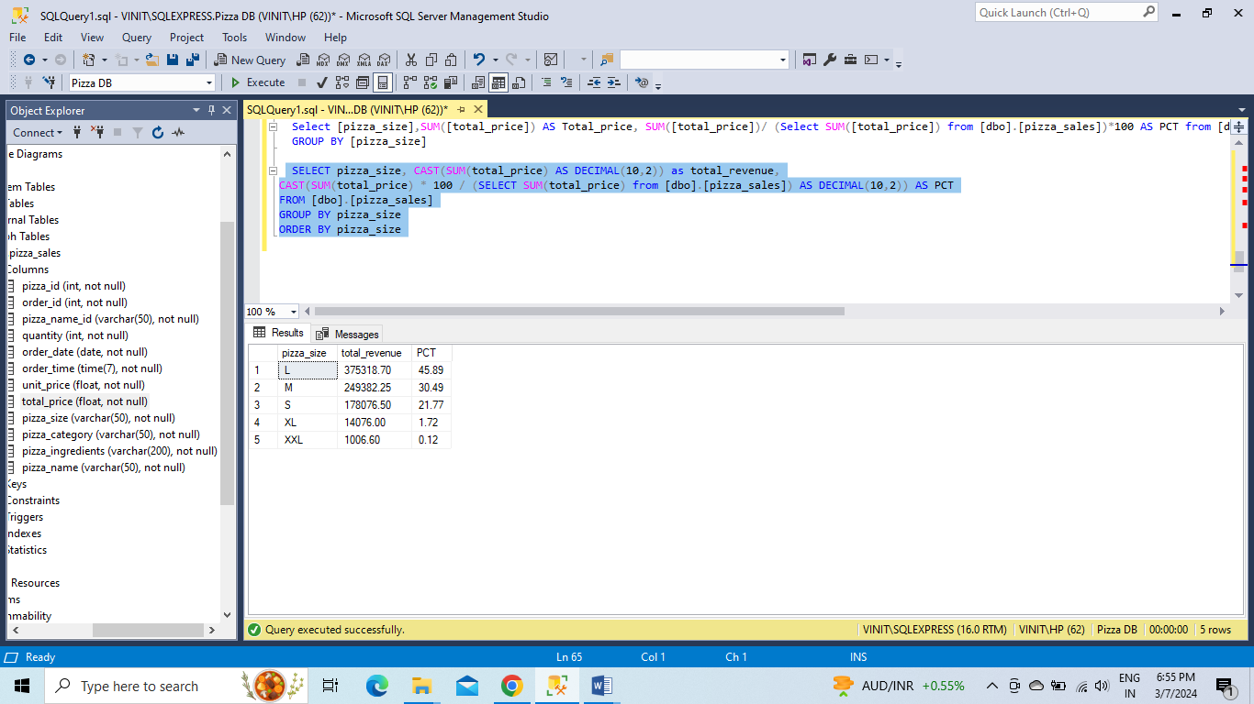

**1st Quarter % of Sales by Pizza Size**

SELECT pizza_size, CAST(SUM(total_price) AS DECIMAL(10,2)) as total_revenue,

CAST(SUM(total_price) * 100 / (SELECT SUM(total_price) from [dbo].[pizza_sales] WHERE DATEPART(quarter, [order_date])=1) AS DECIMAL(10,2)) AS PCT

FROM [dbo].[pizza_sales]

WHERE DATEPART(quarter, [order_date])=1

GROUP BY pizza_size

ORDER BY PCT DESC

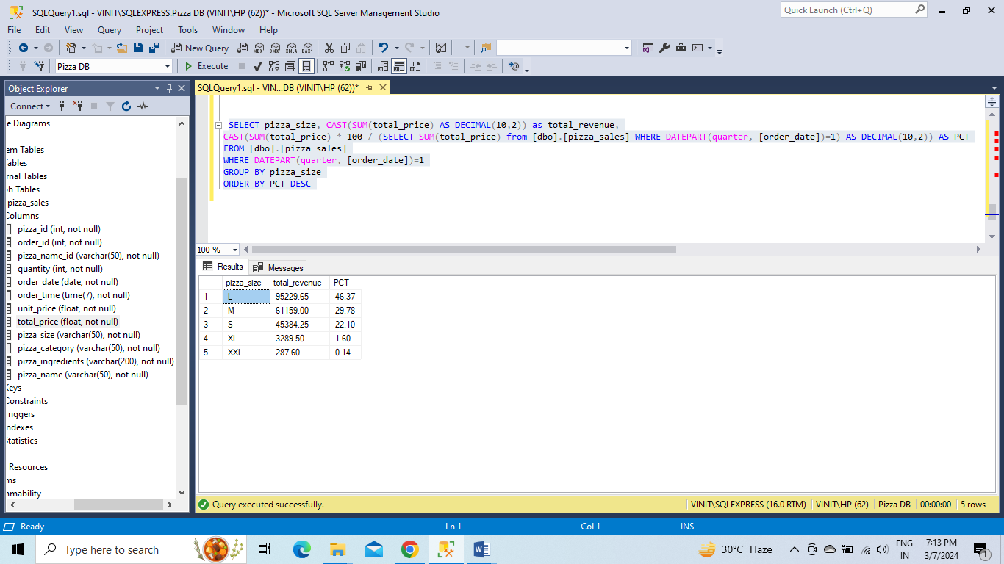

**Top 5 Pizzas by Revenue**

Select TOP 5 [pizza_name],SUM([total_price]) AS Total_revenue from [dbo].[pizza_sales]

GROUP BY [pizza_name]

ORDER BY Total_revenue DESC

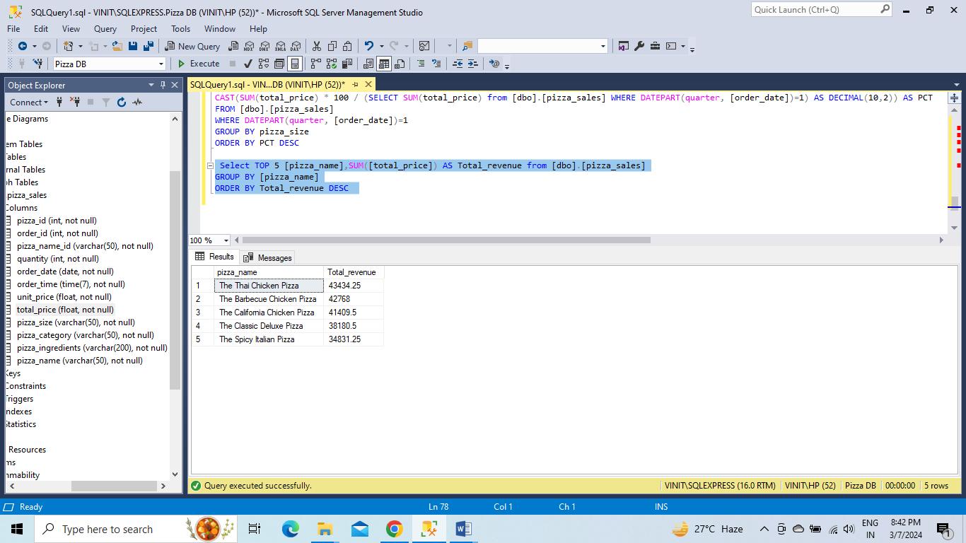

**T**

**Bottom 5 Pizzas by Revenue**

Select TOP 5 [pizza_name],SUM([total_price]) AS Total_revenue from [dbo].[pizza_sales]

GROUP BY [pizza_name]

ORDER BY Total_revenue ASC

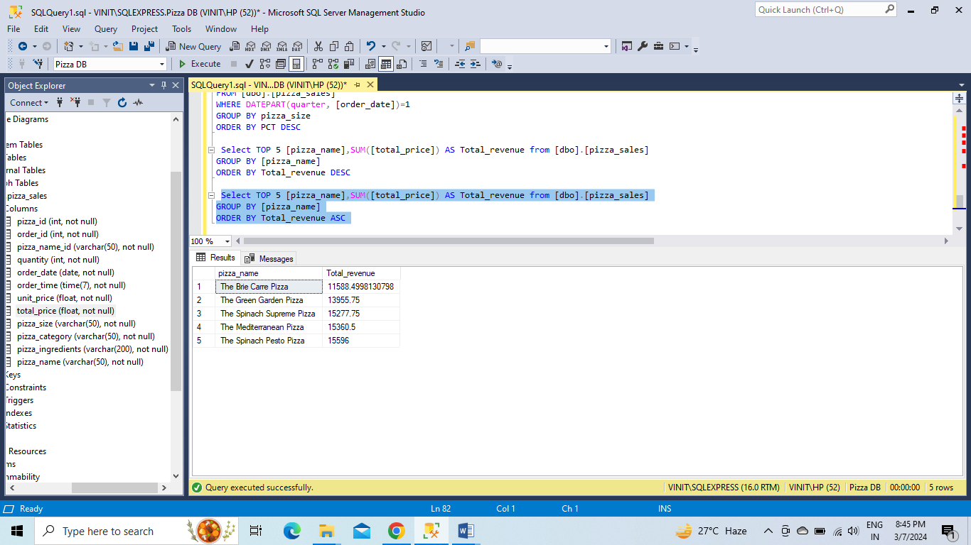

**TOP 5 PIZZAS BY QUANTITY**

Select TOP 5 [pizza_name], SUM([quantity]) AS Quantity from [dbo].[pizza_sales]

GROUP BY [pizza_name]

ORDER BY Quantity DESC

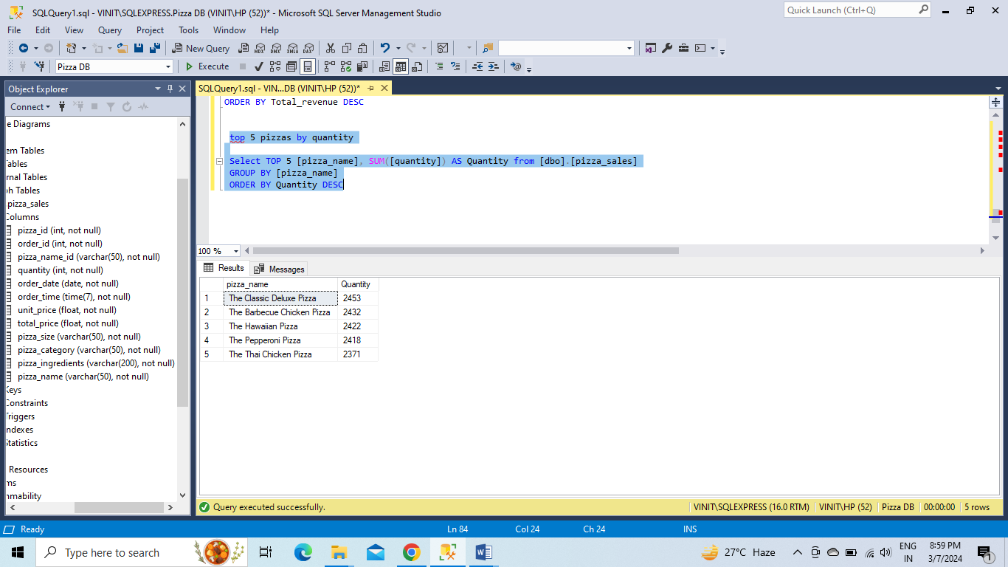

**BOTTOM 5 PIZZAS BY QUANTITY**

Select TOP 5 [pizza_name],SUM([quantity]) AS Quantity from [dbo].[pizza_sales]

GROUP BY [pizza_name]

ORDER BY Quantity

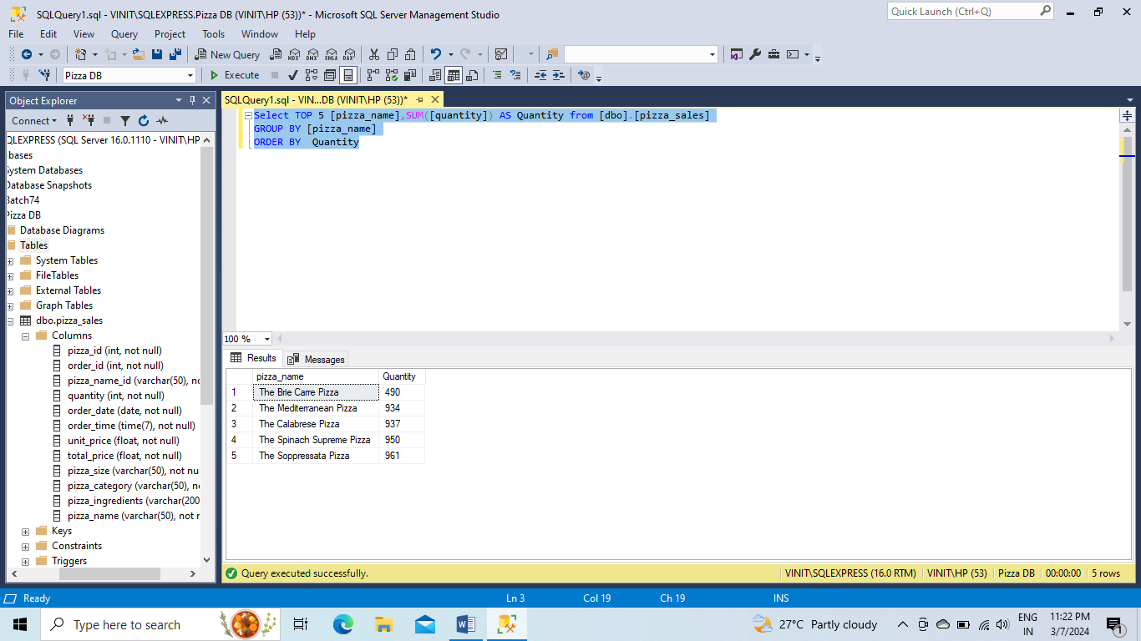

**TOP 5 PIZZAS BY TOTAL ORDERS**

Select TOP 5 [pizza_name], COUNT (DISTINCT [order_id]) AS Total_orders FROM [dbo].[pizza_sales]

GROUP BY [pizza_name]

ORDER BY Total_orders DESC

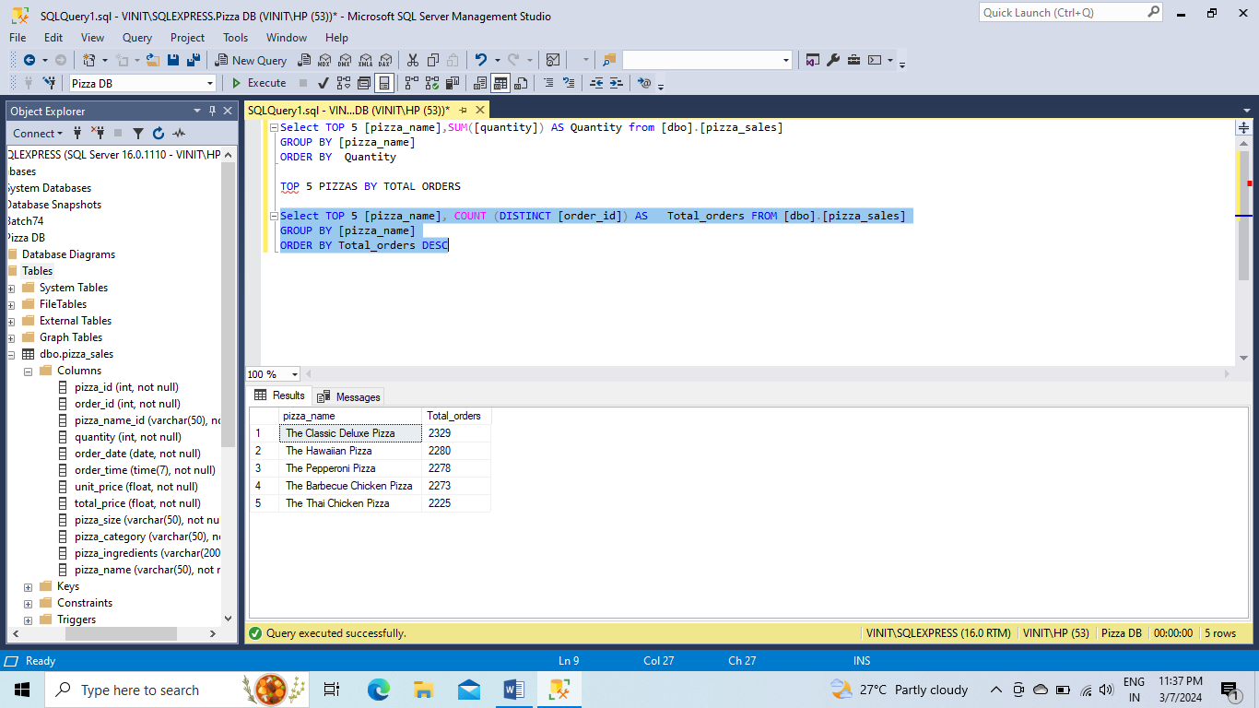

**BOTTOM 5 PIZZAS BY TOTAL ORDERS**

Select TOP 5 [pizza_name], COUNT (DISTINCT [order_id]) AS Total_orders FROM [dbo].[pizza_sales]

GROUP BY [pizza_name]

ORDER BY Total_orders ASC

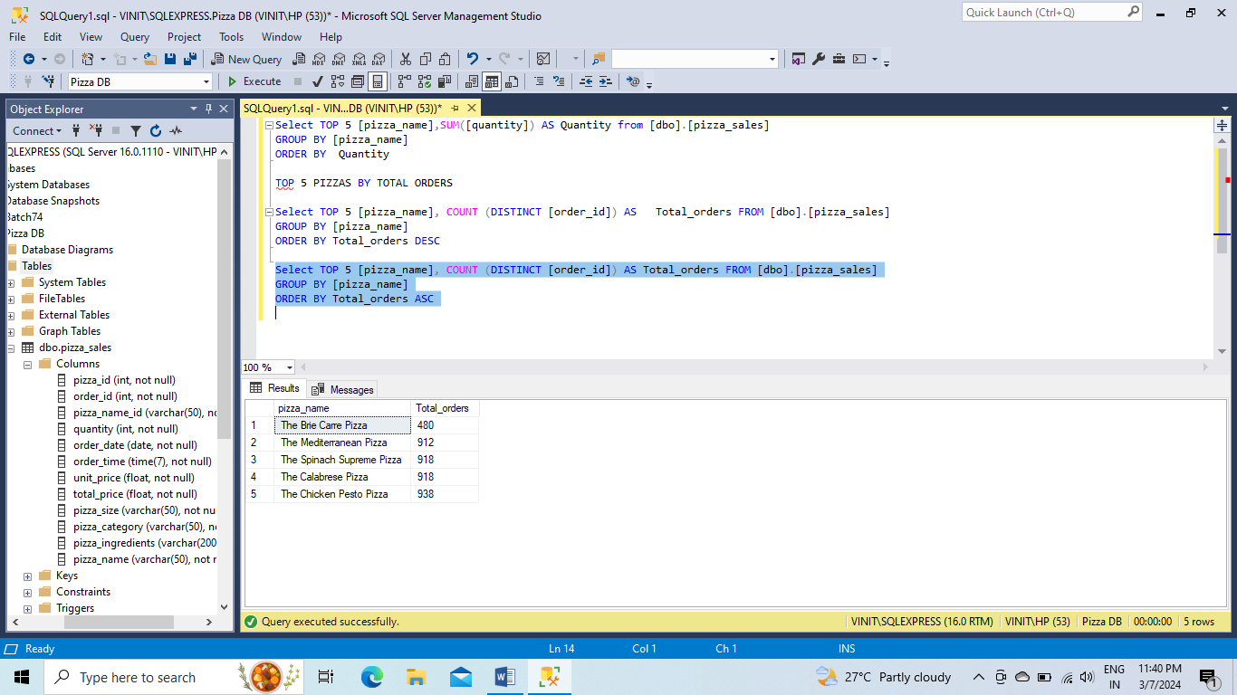

If you want to apply the pizza_category or pizza_size filters to the above queries you can use WHERE clause.

SELECT Top 5 pizza_name, COUNT(DISTINCT order_id) AS Total_Orders

FROM pizza_sales

WHERE pizza_category = 'Classic'

GROUP BY pizza_name

ORDER BY Total_Orders ASC